Running configurations
Router0
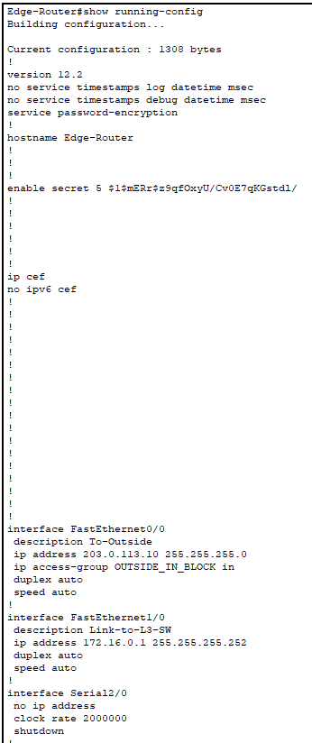
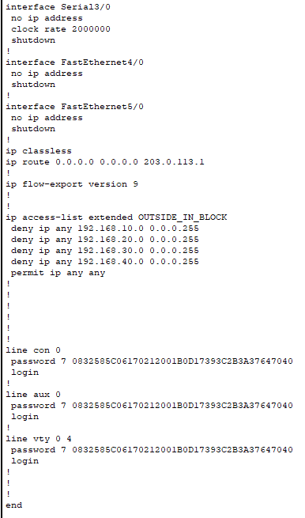
L3 switch
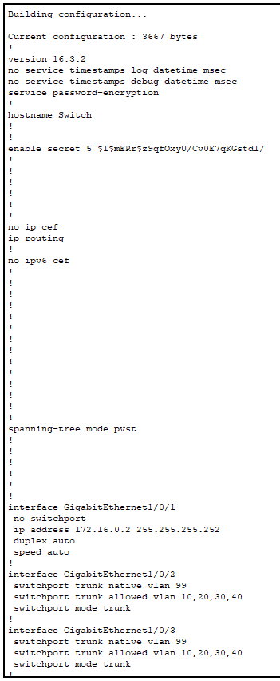

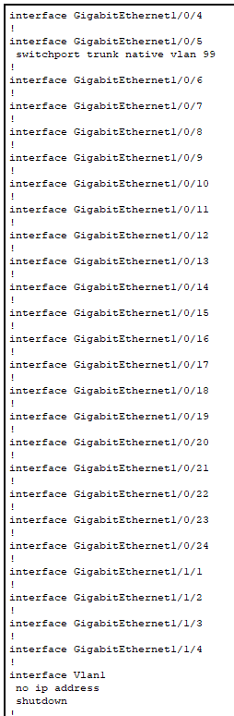

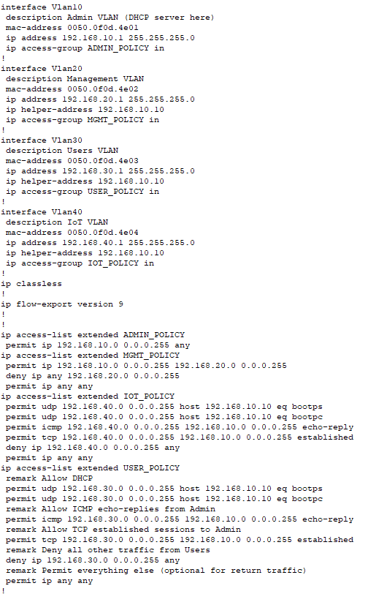

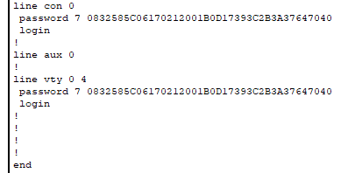
Multilayer switch0 show running configurations

VLANs
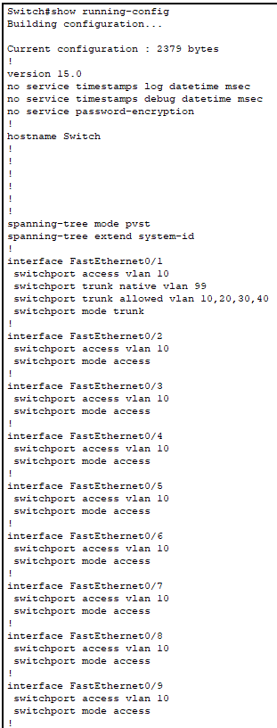

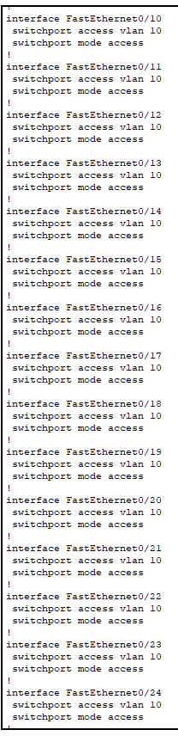

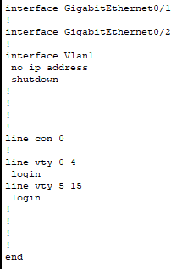
VLAN 10 running configurations

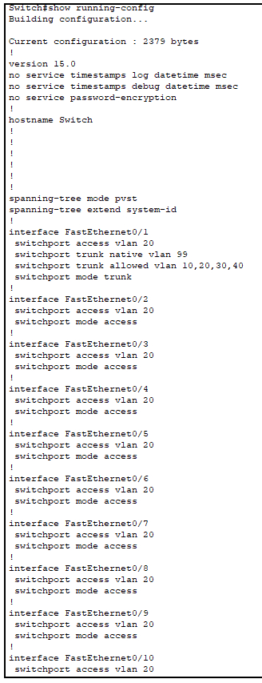

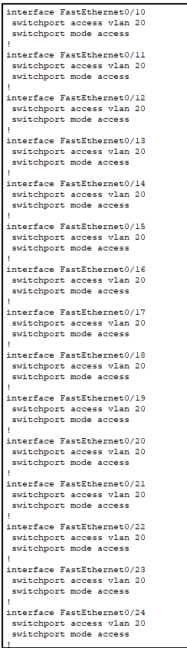

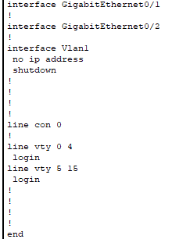
VLAN 20 running configurations

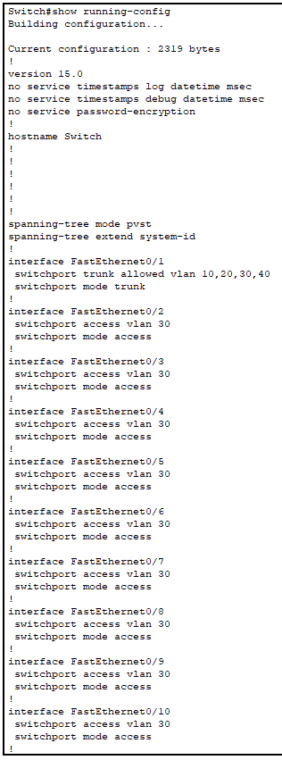

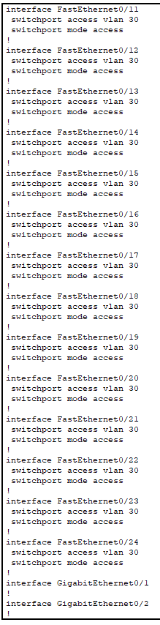

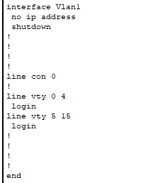
VLAN 30 running configurations

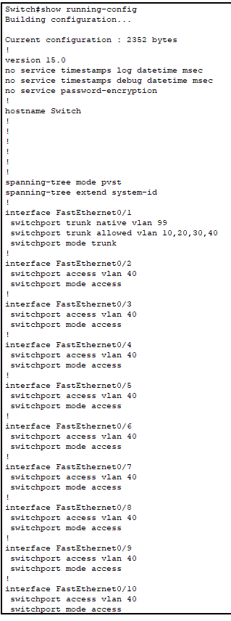

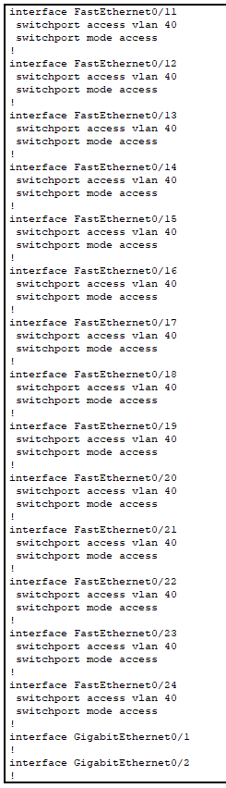

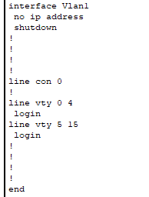
Vlan 40 running configurations

Test Internal Network
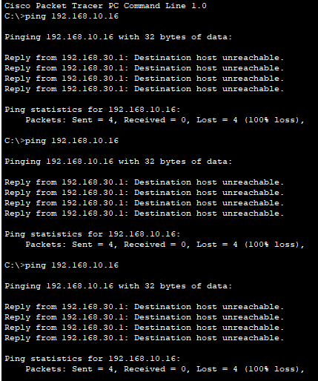
Ping inside attacker vlan 30 to pc1 vlan 10 status: failed
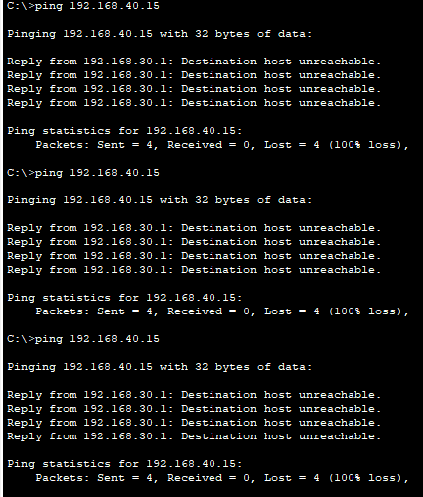
Ping inside attacker vlan 30 to IoT3 vlan 40 status: failed

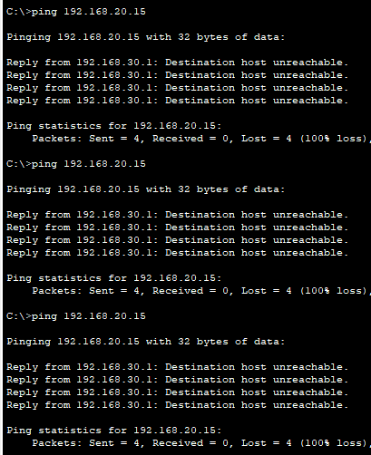
Ping inside attacker vlan 30 to pc4 vlan 20 status:failed

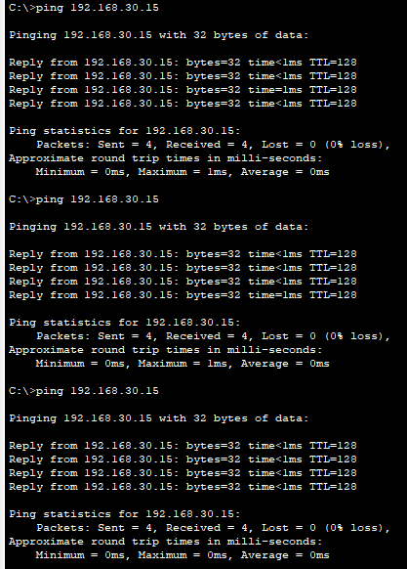
Ping inside attacker vlan 30 to pc5 vlan 30 status: success

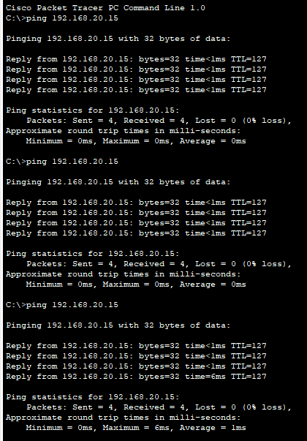
Ping pc1 vlan 10 to IoT3 vlan 40 status: success

Ping pc1 vlan 10 to pc4 vlan 20 status: success

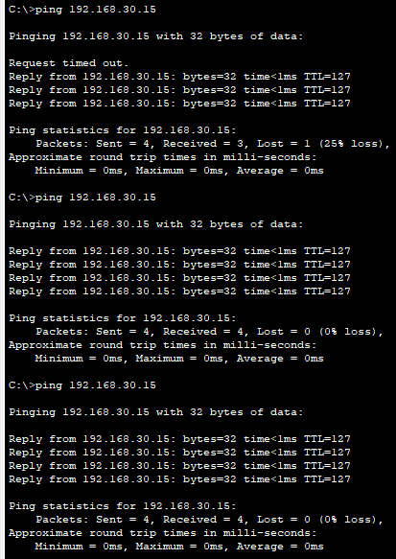
Ping pc1 to pc5 vlan 30 status: success

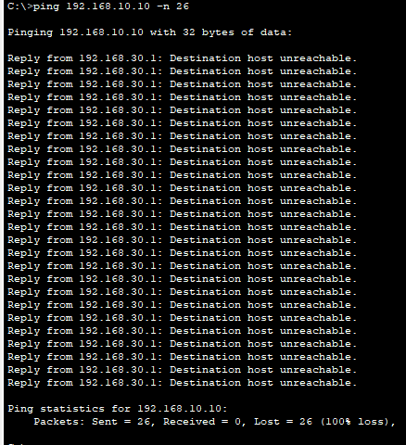
Inside attacker DoS attack attempt status: failed

Test Outside attacker
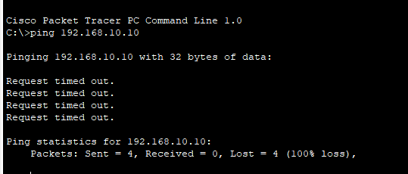
Ping outside attacker to dhcp server status: failed
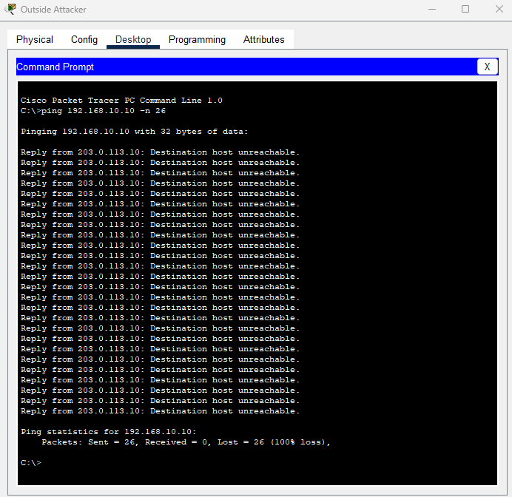
Outside attacker DoS attack attempt status: failed

